FIBROTOR® VR. NC
MORE PRECISE, STRONGER, FASTER

The compact rotary table FIBROTOR VR.NC is designed for flexible movement tasks and is freely programmable. Thus, the series is ideal for use in automated assembly processes. With an optimal sealing concept and high performance data, the FIBROTOR VR.NC. can also be used as a rotary drum version (horizontal axis of rotation).

The round table scores among other things through:
- Flexible drive arrangement
- Flexible connection options for a wide variety of engine brands
- High power density
- Extremely easy re-engineering due to a standardized construction height

AT A GLANCE

- More Precise
- Indexing accuracy ± 20“
- Repeatability ± 5“
- Stronger
- Possible axial load upto 17,500 kg
- Diameter up to 8800 mm possible
- Faster
- Due to the available torque, more mass can be moved and positioned faster.

Video: https://www.youtube.com/watch?time_continue=9&v=sixgIV8OtN8&embeds_euri=https%3A%2F%2Fwww.fibro.de%2F&source_ve_path=MTM5MTE3LDIzODUx&feature=emb_title

Product Image sequence
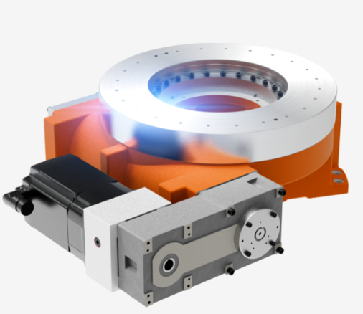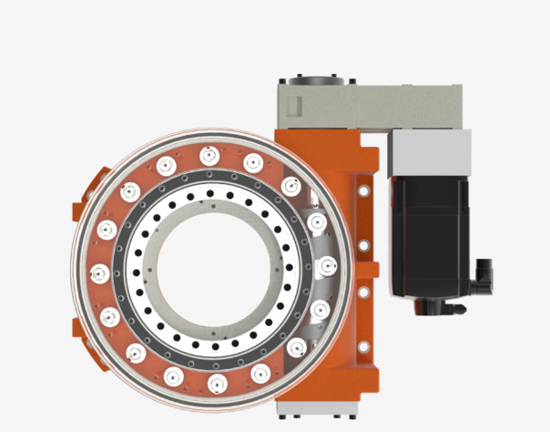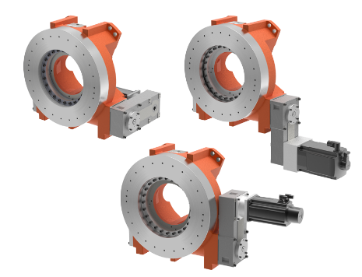

BENEFITS
- Attractive delivery times from 5 weeks on
- Considerably more powerful rotary table at a lower price
- Improved technical data compared to previous models
- Durable and easy service with global availability
- Lubricated for Life long and Maintenance Free

DOWNLOADS
DATASHEET
CALCULATION

